NBKRIST

POWER ELECTRONICS LECTURE NOTES
UNIT-3
I.PRABHAKAR REDDY & G.VIJAYKRISHNA
DEPARTMENT OF ELECTRICAL AND ELECTRONICS ENGINEERING

III Unit - CHOPPERS
3.0 Introduction
A chopper is a static device which converts constant dc voltage to variable dc voltage. A chopper is also known as dc-to-dc converter. The power source for the chopper could be a battery or a rectified a.c. The power switch can be a BJT, MOSFET, IGBT or SCR. BJT, MOSFET or IGBT requires base, or gate driver, circuits to turn the switch on, and they turn off when the driver pulse is removed. But SCR requires a separate commutation circuit to turn off it. This complication tends to rule out the thyristor for all but very high power circuits.
The thyristor converter offers greater efficiency, faster response, lower maintenance, smaller size and smooth control. These are widely used in trolley cars, battery operated vehicles, dc motors control. They are also used in regenerative braking of dc motors to return energy back to supply and also as dc voltage regulators
Based on input/output voltage levels: there are two types of dc choppers
- Step-down choppers.
  - In step down chopper output voltage is less than input voltage.
- Step-up choppers.
  - In step up chopper output voltage is more than input voltage.

3.1 Step-Down Chopper:
Typical step down chopper circuit and waveforms is shown in figure 3.1 with a load resistance R. The switch, SCR is assumed to be ideal with zero voltage across it when 'on', and full battery voltage across it when 'off'. When thyristor is ON, supply voltage appears across the load and when thyristor is OFF, the voltage across the load will be zero. The output voltage and current waveforms are as shown in figure 3.1below.
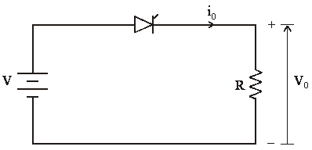

Fig.3.1: Step down chopper and Waveforms
= average value of output or load voltage
= average value of output or load current
= time interval for which SCR conducts
= time interval for which SCR is OFF.
= period of switching or chopping period
Chopper switching frequency or chopping frequency.
Average output voltage
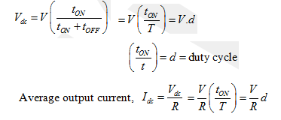
RMS value of output voltage
But during
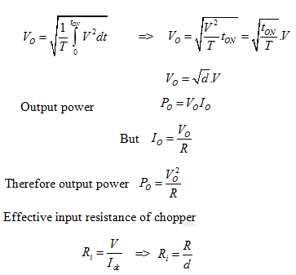
The output voltage can be varied by varying the duty cycle.

3.2 Methods of output voltage control:
- The output dc voltage of dc choppers can be varied by the following methods.
- Time-ratio control
- Pulse width modulation control or constant frequency operation
- Variable frequency control
- Current limit control

3.2.1 Time-ratio control:
In the time ratio control the value of the duty ratio, is varied. There are two ways, which are constant frequency operation, and variable frequency operation.

3.2.1.1 Constant frequency operation:
In this control strategy, the ON time, is varied, keeping the frequency or time period T constant. This is also called as pulse width modulation (PWM) control.
Two cases with duty ratios, as (a) 0.25 (25%), and (b) 0.75 (75%) are shown in figure 3.2 below. Hence, the output voltage can be varied by varying ON time, T_{ON}.
Fig 3.2 pulse width modulation scheme

3.2.1.2 Variable frequency operation:
- In this method of control, chopping frequency f is varied keeping either or constant. This method is also known as frequency modulation.
- Figure 3.3 shows the output voltage waveforms for a constant T_{ON} and variable chopping period T.
- In frequency modulation to obtain full output voltage, range frequency has to be varied over a wide range. This method produces harmonics in the output and for large load current may become discontinuous.

Fig 3.3 Frequency modulation scheme

There are major disadvantages in this control strategy. These are:
a) The frequency has to be varied over a wide range for the control of output voltage in frequency modulation. Filter design for such wide frequency variation is, therefore, quite difficult.
b) For the control of a duty ratio, frequency variation would be wide. As such, there is a possibility of interference with systems using certain frequencies, such as signaling and telephone line, in frequency modulation technique.
c) The large OFF time in frequency modulation technique, may make the load current discontinuous, which is undesirable.
Thus, the constant frequency system using PWM is the preferred scheme for dc-dc converters.

3.2.2 Current limit control:
In the current limit control strategy, the switch in dc-dc converter (chopper) is turned ON and OFF, so that the current is maintained between two (upper and lower) limits as shown in figure 3.4. When the current exceed upper (maximum) limit, the switch is turned OFF. During OFF period, the current freewheels through the diode and decreases exponentially. When it reaches lower (minimum) limit, the switch is turned ON. This type of control is possible, either with constant frequency or constant ON time. This is used only, when the load has energy storage elements, i.e. inductance, L. The reference values are load current or load voltage.

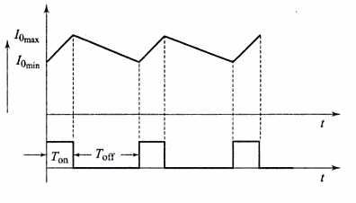
Fig 3.4 current limit control
3.4 Principle of Step-Up Chopper

Fig. 3.5 : Step-up Chopper
Figure 3.5 shows a step-up chopper to obtain a load voltage higher than the input voltage V. The values of L and C are chosen depending upon the requirement of output voltage and current. When the chopper is ON, the inductor L is connected across the supply. The inductor current ‘I’ rises and the inductor stores energy during the ON time of the chopper, . When the chopper is off, the inductor current I is forced to flow through the diode D and load for a period, . The current tends to decrease resulting in reversing the polarity of induced EMF in L. Therefore voltage across load is given by
If a large capacitor ‘C’ is connected across the load then the capacitor will provide a continuous output voltage . Diode D prevents any current flow from capacitor to the source. Step up choppers are used for regenerative braking of dc motors.
EXPRESSION FOR OUTPUT VOLTAGE
Assume the average inductor current to be I during ON and OFF time of Chopper.
When Chopper is ON
Voltage across inductor
Therefore energy stored in inductor =,
where period of chopper.
When Chopper is OFF (energy is supplied by inductor to load)
Voltage across
Energy supplied by inductor, where period of Chopper.
Neglecting losses, energy stored in inductor L = energy supplied by inductor L
Therefore
=>
Where T = Chopping period or period of switching.
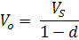
Where d = duty ratio = 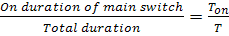
For variation of duty cycle‘d’ in the range of the output voltage will vary in the range .
PERFORMANCE PARAMETERS
The thyristor requires a certain minimum time to turn ON and turn OFF. Hence duty cycle d can be varied only between a minimum and a maximum value, limiting the minimum and maximum value of the output voltage. Ripple in the load current depends inversely on the chopping frequency, f. Therefore to reduce the load ripple current, frequency should be as high as possible.
3.5 CLASSIFICATION OF CHOPPERS
Choppers are classified as follows:1) Class A Chopper 2) Class B Chopper
3) Class C Chopper 4) Class D Chopper 5) Class E Chopper
3.5.1 CLASS A CHOPPER
Fig 3.6: Class A Chopper and Characteristic
Figure 3.6 shows a Class A Chopper circuit with inductive load and free-wheeling diode. When chopper is ON, supply voltage V is connected across the load i.e., and current i0 flows as shown in figure. When chopper is off, v0 = 0 and the load current continues to flow in the same direction through the freewheeling diode. Therefore the average values of output voltage and current i.e., and are always positive. Hence, Class A Chopper is a first quadrant chopper (or single quadrant chopper). Figure 3.7 below shows output voltage and current waveforms for a continuous load current.
Fig 3.7 : First quadrant Chopper - Output Voltage and Current Waveforms
Class A Chopper is a step-down chopper in which power always flows from source to load. It is used to control the speed of dc motor. The output current equations obtained in step down chopper with R-L load can be used to study the performance of Class A Chopper.
CLASS B CHOPPER
Fig 3.8: Class B Chopper
Fig.3.8 shows a Class B Chopper circuit. When chopper is ON, and E drives a current through L and R in a direction opposite to that shown in figure 2.16. During the ON period of the chopper, the inductance L stores energy. When Chopper is OFF, diode D conducts, and part of the energy stored in inductor L is returned to the supply. Also the current continues to flow from the load to source. Hence the average output voltage is positive and average output current is negative. Therefore Class B Chopper operates in second quadrant. In this chopper, power flows from load to source. Class B Chopper is used for regenerative braking of dc motor. Figure 3.9 shows the output voltage and current waveforms of a Class B Chopper.

Fig 3.9 : Class B Chopper - Output Voltage and Current Waveforms

CLASS C CHOPPER
Class C Chopper is a combination of Class A and Class B Choppers. Figure 3.10 shows a Class C two quadrant Chopper circuit. For first quadrant operation, is ON or conducts and for second quadrant operation, is ON or conducts. When is ON, the load current is positive. i.e., flows in the direction as shown in figure.
The output voltage is equal to and the load receives power from the source.
Fig3.10 : Class C Chopper
When is turned off, energy stored in inductance L forces current to flow through the diode and the output voltage , but continues to flow in positive direction. When is triggered, the voltage E forces to flow in opposite direction through L and. The output voltage. On turning OFF, the energy stored in the inductance drives current through diode and the supply; output voltage the input current becomes negative and power flows from load to source.
Thus the average output voltage is positive but the average output current can take both positive and negative values. Choppers and should not be turned ON simultaneously as it would result in short circuiting the supply. Class C Chopper can be used both for dc motor control and regenerative braking of dc motor. Figure 3.11 shows the output voltage and current waveforms.
Fig 3.11: Class C Chopper - Output Voltage and Current Waveforms

CLASS D CHOPPER
Fig.3.12 : Class D Chopper
Figure 3.12 shows a class D two quadrant chopper circuit. When both and are triggered simultaneously, the output voltage and output current flows through the load in the direction shown in figure . When and are turned OFF, the load current continues to flow in the same direction through load, and , due to the energy stored in the inductor L, but output voltage . The average load voltage is positive if chopper ON-time is more than their off-time and average output voltage becomes negative if . Hence the direction of load current is always positive but load voltage can be positive or negative. Waveforms are shown in figures 3.13 and 3.14
Fig. 3.13: Output Voltage and Current Waveforms for
Fig. 3.14: Output Voltage and Current Waveforms for

CLASS - E CHOPPER
Fig. 3.15: Class E Chopper
Fig 3.16: Four Quadrant Operation
Figure 3.15 shows a class E 4 quadrant chopper circuit. When and are triggered, output current flows in positive direction as shown in figure 3.16 through and , with output voltage . This gives the first quadrant operation. When both and are off, the energy stored in the inductor L drives through and in the same direction, but output voltage . Therefore the chopper operates in the fourth quadrant. For fourth quadrant operation the direction of battery must be reversed. When and are triggered, the load current flows in opposite direction and output voltage.
Since both and are negative, the chopper operates in third quadrant. When both and are off, the load current continues to flow in the same direction through and and the output voltage. Therefore the chopper operates in second quadrant as is positive but is negative. Figure 6.23(a) shows the devices which are operative in different quadrants.

DC Jones chopper or Voltage Commutated chopper

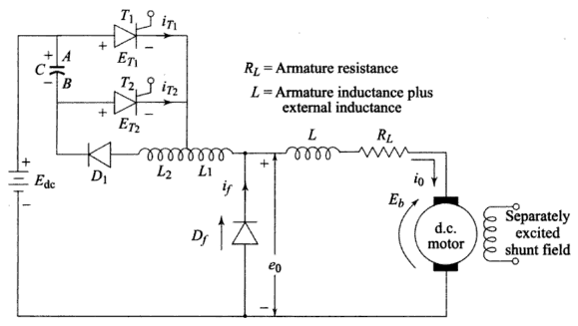

Fig 3.17(a) DC Jones chopper

The fig.3.17(a) shows the Jones chopper is an example of class D commutation in which a charged capacitor is switched by an auxiliary SCR to commutate the main SCR. In this circuit SCR1 is the main switch and SCR2 is the auxiliary switch which is of lower capacity than SCR1 and is used to commutate SCR1 by a reverse voltage developed across the capacitor C. "The special feature of the circuit is the tapped autotransformer T through a
portion of which the load current flows".
Working
When T1 is ON, capacitor C discharges resonantly through T1, L2, D1. This discharge current does not flow through L1 and back to the battery because of transformer action. The load current is picked up by T1 and the freewheel diode D1 is reverse biased. As the capacitor voltage swings negative, the reverse bias on diode Df decreases. This continues up
to a time pi(L1C)^1/2.
When T2 is on the negative voltage on capacitor C is applied across T1 and it becomes OFF. The load current which is normally constant starts to flow in T2 and capacitor C. The capacitor C charged positively at first up to a voltage equal to supply voltage Vdc. The freewheel diode become forward bias and begins to pickup load current. And capacitor current starts to reduce. After this the energy 1/2LI^2 is the inductance L2 is forced in to the capacitor C. Charging is positively to 1/2CV^2 the capacitor current continues to decrease as a result current through T2 decreases gradually become OFF. The cycle repeat when T1 is again turned ON. The related wave forms are shown in fig.3.17(b)
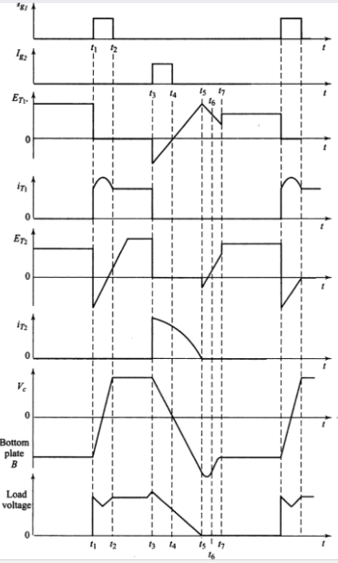

Fig.3.17(b) The related wave forms

Advantages:
The main advantage of JONES chopper over other the circuit is that
- It allows the use of higher voltage and lower microfarad commutating capacitor. This is because the trapped energy of inductor L2 can be forced in to the commutating capacitor rather than simply charging the capacitor by supply voltage.
- In this circuit there is no starting problem and anyone of the SCR can be turned on initially there is great flexibility in control also.
Morgan’s chopper (Current commutated chopper)
The circuit of Fig. 3.18(a) shows the power circuit of Morgan chopper. In this circuit, T1 is main thyristor and capacitor C, saturable reactor SR and D1 forms the commutating circuit. The exciting current of SR is negligible when SR is saturated and it has very low inductance. The voltage and current waveforms of Morgan-chopper is shown in Fig,
When then main SCR T1 is OFF, capacitor C will charge to the supply voltage Edc with the polarity as shown in fig. and SR is placed in the positive saturation condition.
As shown in fig. 3.18(b) SCR T1 is triggered at time t=t1. When T1 is turned-on, the capacitor voltage appears across the SR and the core flux is driven from the positive saturation to negative saturation. The capacitor voltage remains essentially with the same polarity, till the negative saturation point is reached. This is due to the negligible exciting current of the SR. thus, the discharging time of the capacitor takes place very quickly. After this, the capacitor voltage which is now –Edc is impressed on the saturable reactor in the reverse direction and the core is driven from negative saturation towards positive saturation.
After a fixed interval of time, the core flux reaches the positive saturation after which the capacitor discharges very quickly through SCR T1 in the reverse direction and the post-saturation inductance as before.the discharge current first passes through SCR T1, turning it OFF and then through diode D1.
When SCR T1 is turned off the load current current flows through freewheeling diode Df. The ON period is a function of LsC and the average output voltage can be altered by varying the operating frequency.

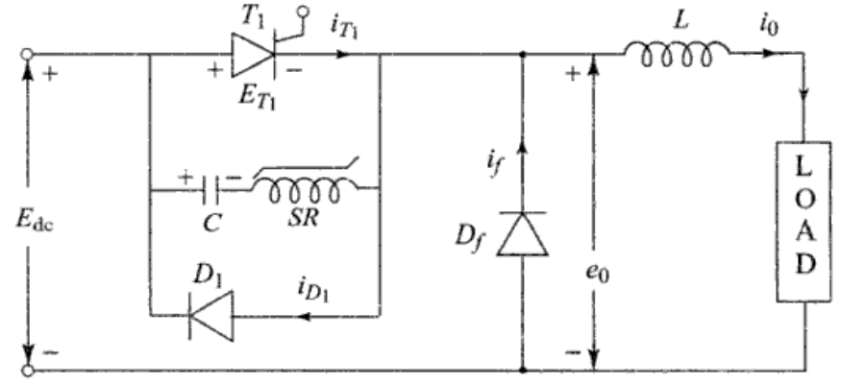
Fig. 3.18(a) Morgan Chopper

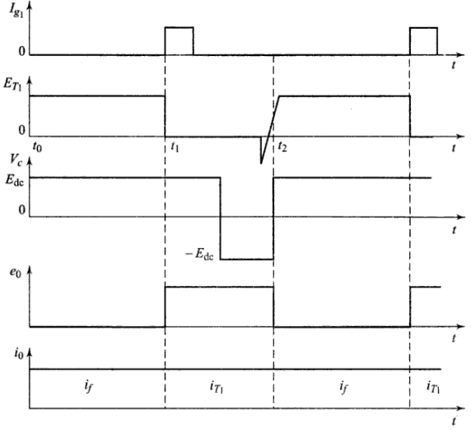
Fig. 3.18(b) Most significant waveforms

Load Commutated chopper
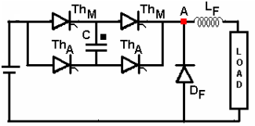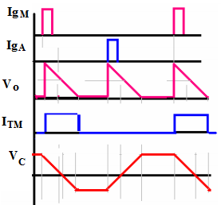
Fig 3.19 load commutated chopper and waveforms
The circuit in Fig 3.19 is shows the load-commutated chopper and its wave forms. Conduction paths are alternately through the diagonal SCR pairs. Conduction patterns of these two groups are symmetrical. Each pair of SCRs conducts with the capacitor in series. The current thus automatically is extinguished when the capacitor achieves supply voltage level and the free-wheeling diode is turned on. Any value of capacitor will sufficient for commutation. In fact it is chosen to satisfy the load current requirement. This commutation method permits fastest switching of the SCRs. Currents through the SCRs rise and fall sharply without any inductance regulating it. The freewheeling diode current also behaves similarly and all devices are stressed by sharp di/dt. The load voltage is of triangular shape with a peak equal to double the supply voltage (average equal to supply voltage for the conduction interval). The capacitor has a symmetric trapezoidal voltage across itself.

